# **HOPE 4 PAWS (Domain Study)**

**Description:**

This article includes a detailed analysis of current systems that function similarly to the Hope4Paws project. The systems under investigation have technology that could be helpful to the project and support the domain area. Technologies that are also disadvantageous are not disregarded as they help to point out what to avoid.

*Animal Intake and Registration*:

1. **Website:** us01d.sheltermanager.com/animal_new

* **Feature:** Allowing an administrative staff to register an animal that has been stray, rescued or surrendered.
* **Screenshot:**

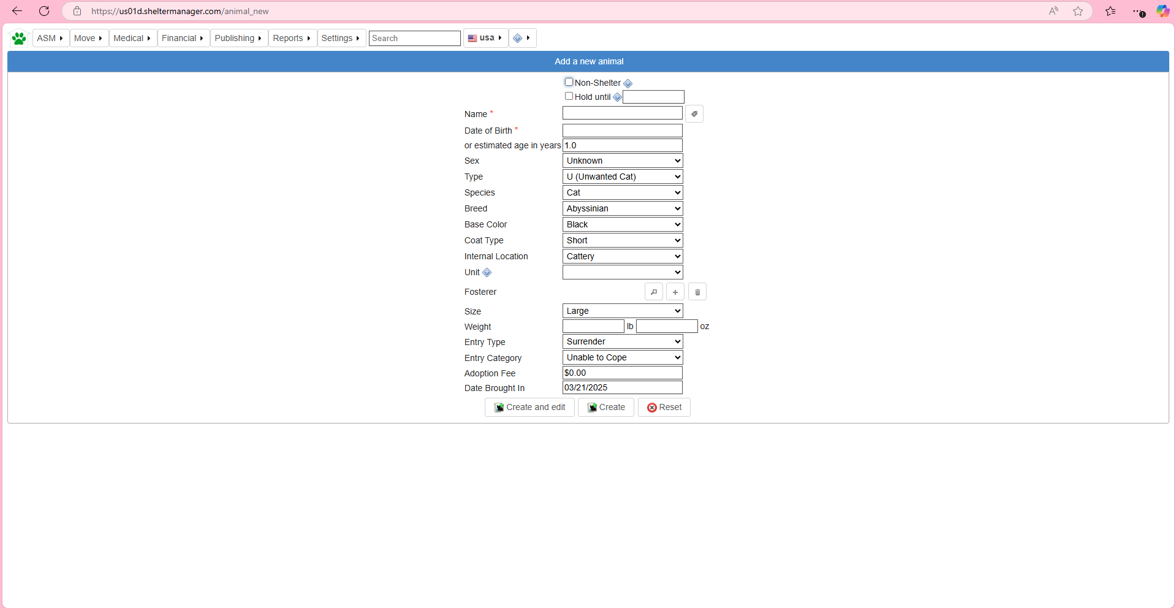

* **Why is it useful:** This allows the users of the system to know what animals are currently being sheltered and also helps keep track of the animal intake, with the animal details being kept for every animal. Which makes it easier to describe the animal to potential adopters.

1. **Website:** us01d.sheltermanager.com/animal?id=32

* **Feature:** Ability to check an already registered animal and to check for its location.

**Screenshot:**

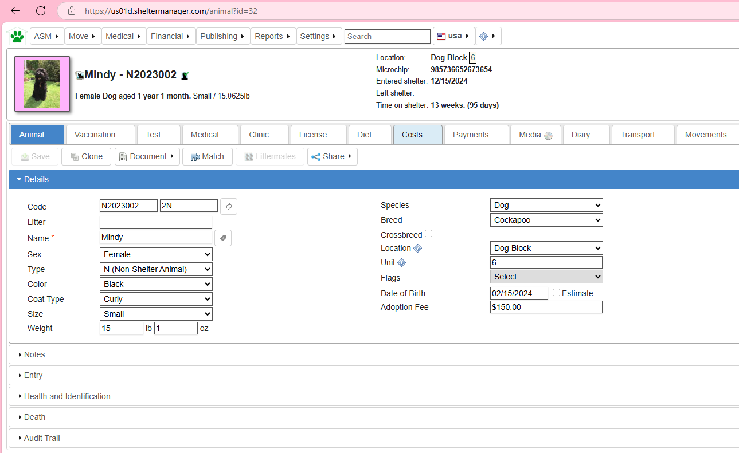

* **Why is it useful:** This will make it easier to find an animal around the shelter. This will also make it easier to deem a location as fully occupied, therefore making it easier to spot an available space for a new intake.

*Medical Care Management*:

1. **Website:** form.jotform.com

* **Feature:** This allows the user to see the available days for booking an appointment and also to book on the same website.
* **Screenshot:**

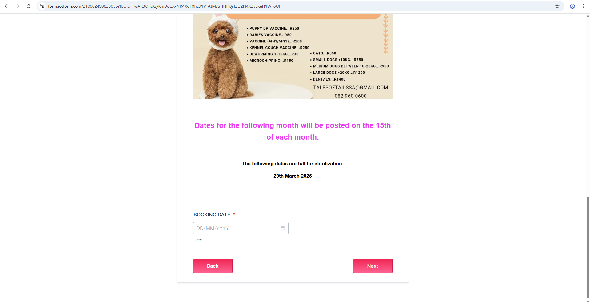

* **Why is it useful:** This is useful because it will allow a user to know what days are full and also allow them book in time. The veterinary staff will also know who they are meeting and in what time slots, to avoid wasting time.

1. **Website:** capespca.co.za

* **Feature:** This website contains a page that educates more about animal vaccines, their importance, their usage, how to use them and also what steps to take to get your pet vaccinated.
* **Screenshot:** 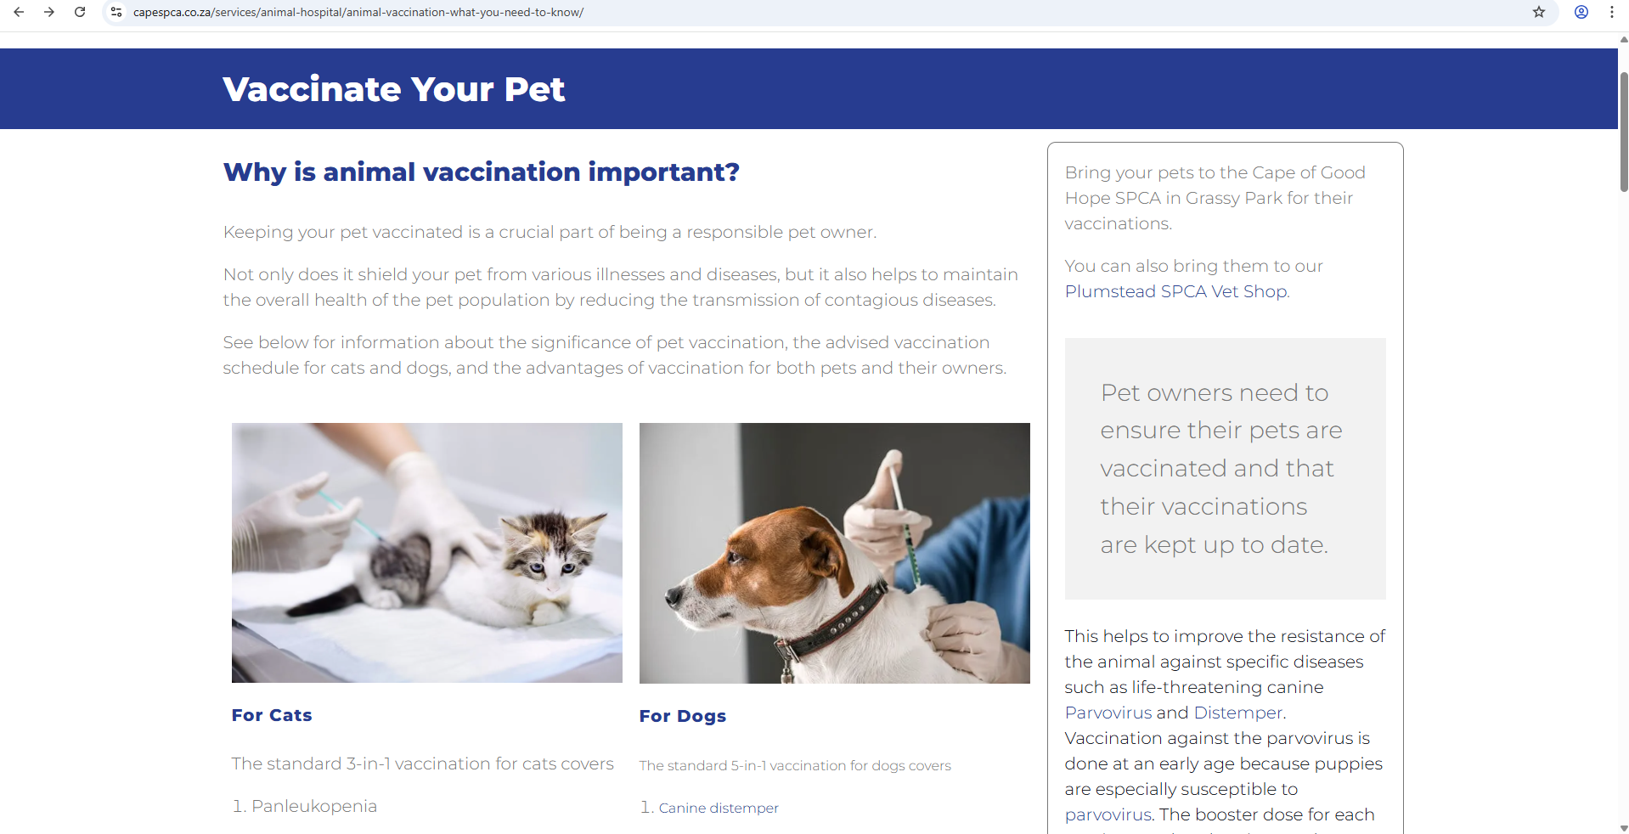
* **Why is it useful:** This is useful because it will let the user know more about vaccines and why their pet needs vaccines and also will guide the user on getting their pet vaccinated.

1. **Website:** us01.sheltermanager.com/animal_vaccination?id=32

* **Feature:** This feature assist with dealing with all thing medical/veterinary for the pets. A user (veterinary) will be able to manage the medical profiles of each and every pet, with the ability amazing functionalities, such as; adding a medical regimen, updating test results, booking for a test and more.
* **Screenshot:**

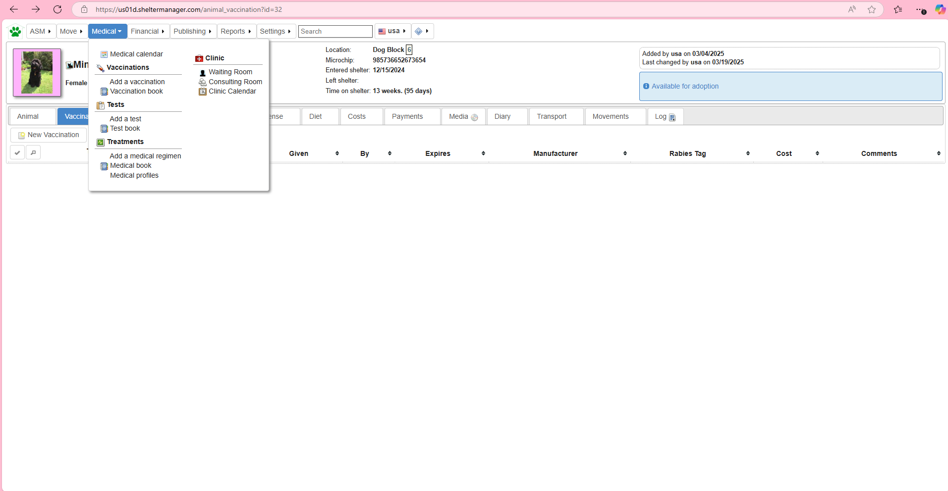

* **Why is it useful:** The above is useful because it provides the user with an easier way to record and manage all of the medial related area.

1. **Website:** animalqi.co.za

* **Feature:** The ability to book a consultation for vaccination/ sterilization and more.
* **Screenshot:**

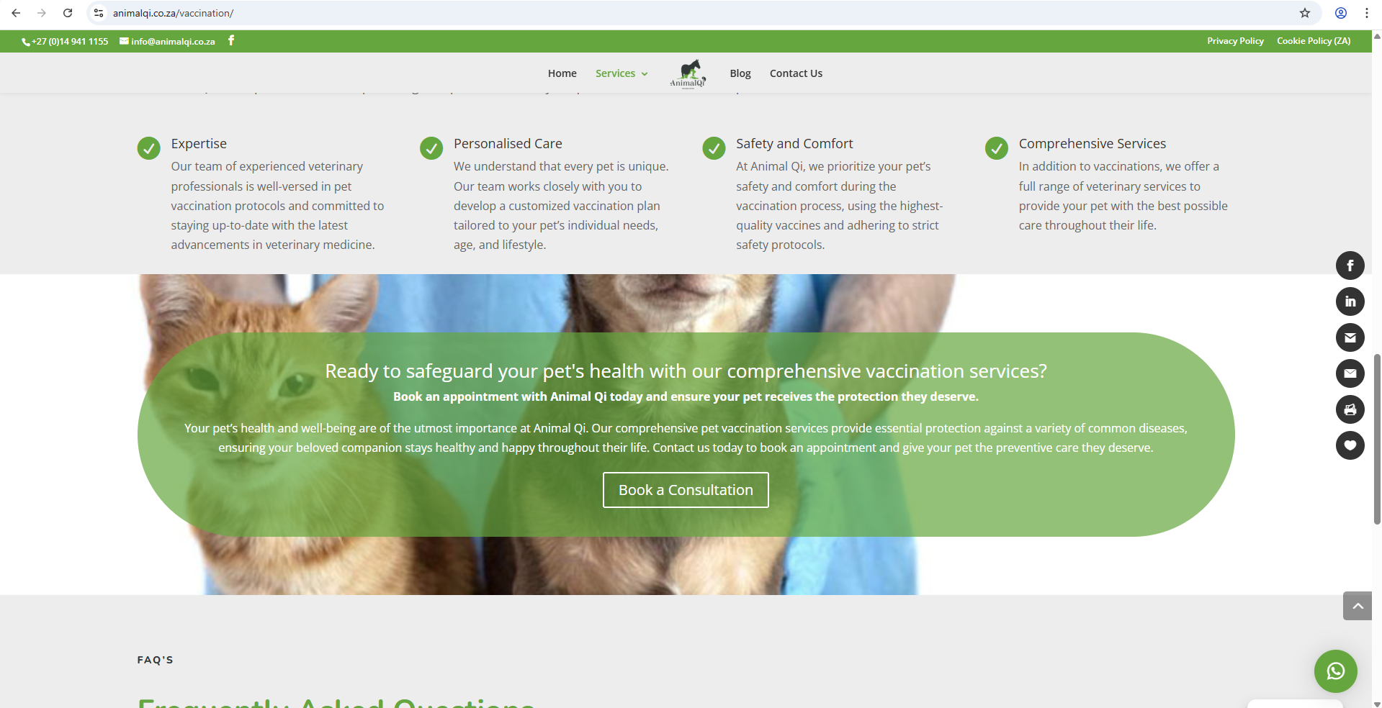

* **Why is it useful:** This will allow a user to book a consultation for their pet easier with more swiftness and thus making is easier to administer vaccines.

*Cruelty Management:*